**Istanbul Residence Guide For Tourists**

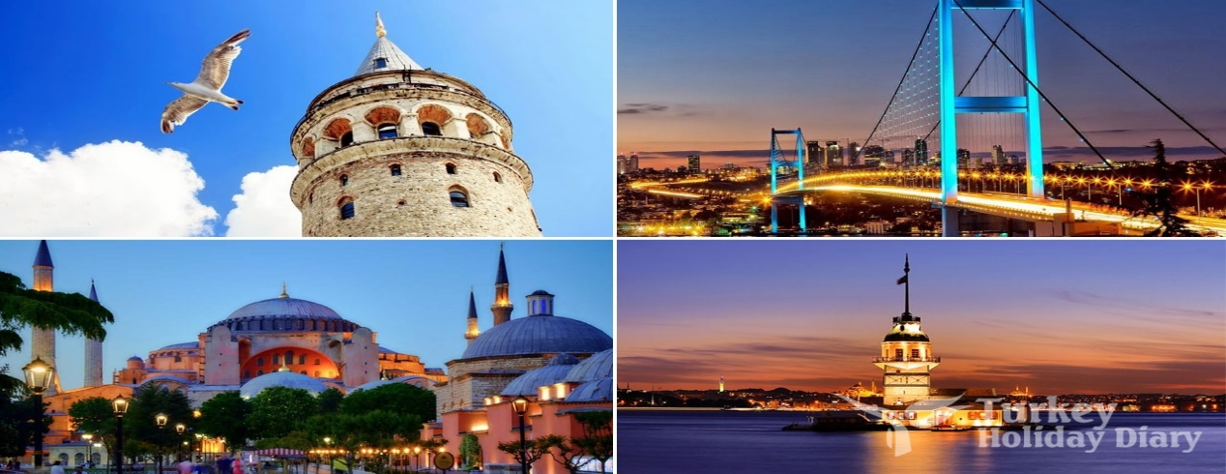

**A.Introduction:**

Istanbul is a dream destination, it’s located in the edge of Europe where east meets west. Connecting the two continents, the city hides layers of history, culture, colors and scents. The architecture, the food, everything in Istanbul tells a story. The city is busy, fast, never stops, but when you need a break from all this fervid life there is always a nice garden, a small tea house or a mosque where you can seat, breath and relax.

As you can see from the figure, Istanbul is a city with a lot of places to visit. But if this is your first trip to this city you may get lost in this spacious city, as it's known Istanbul is a big city but it is divided into 39 districts in total.

So if this is your first trip which district you should choose to stay in, you should consider the tourist sites you like the most to choose the district that contains those sits.

When we consider all these, we can create a map and where the real estate index is placed on Istanbul and each district is clustered according to the venues.

## A.2. Data Description:

To consider the problem we can list the data as below:

1. I used a Wikipedia page that contains a table of Istanbul district, and script it, and clean the data.

2. then I **Geolocation** to get the coordinates of each district.

3. then I used Foursquare API to get most common venues of given District of Istanbul .

# B. Methodology:

As a database I used Wikipedia page to get names of Istanbul districts, and use Geolocation to get the coordinates of each district and put them all in a dataframe.

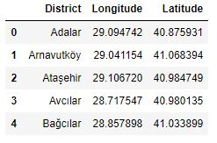

I used python folium library to visualize geographic details of Istanbul and its boroughs and I created a map of Istanbul with districts superimposed on top. I used latitude and longitude values to get the visual as below:

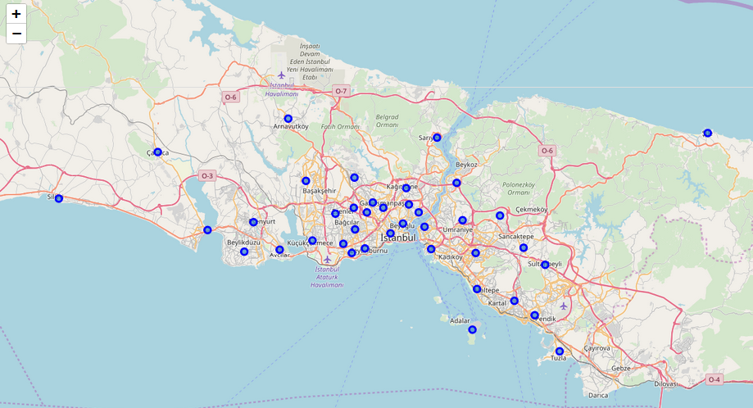

I utilized the Foursquare API to explore the districts and segment them. I designed the limit as 100 venue and the radius 500 meter for each district from their given latitude and longitude information. Here is a head of the list Venues name, category, latitude and longitude information from Forsquare API.

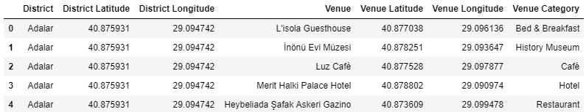

then I created a table which shows list of top 10 venue category for each borough in below table.

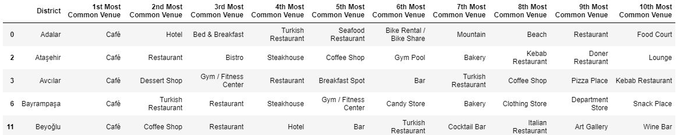We have some common venue categories in boroughs. In this reason I used unsupervised learning **K-means algorithm** to cluster the boroughs. K-Means algorithm is one of the most common cluster method of unsupervised learning.

First, I will run K-Means to cluster the boroughs into **3** clusters .

Here is my merged table with cluster labels for each borough.

# C. Results:

You can also see a clustered map boroughs of Istanbul

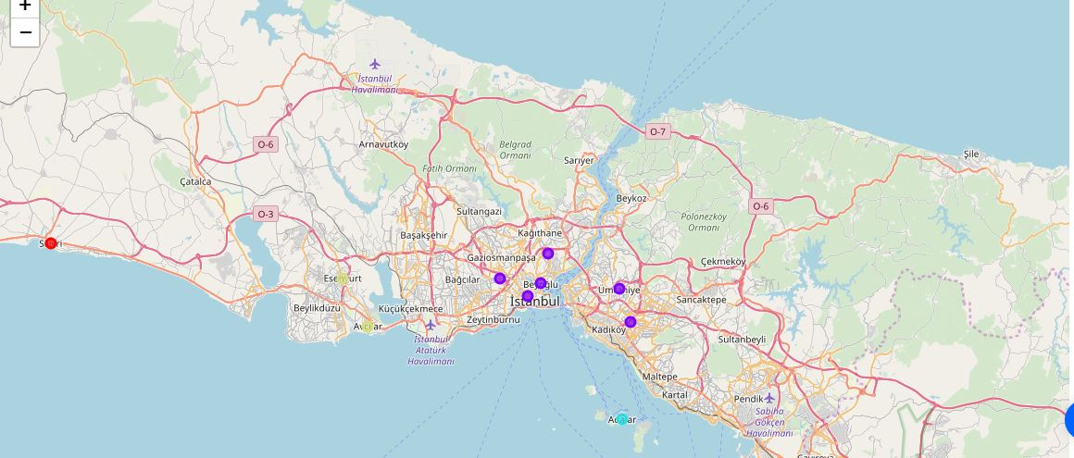In summary section, my aim was visualize the tourist sites with map. Thus, first I scripted a Wikipedia page Istanbul districts. I get the coordinates of each district and put them into dataframe

In final section, I created a map that show each cluster on map.

# D. Discussion:

As I mentioned before, Istanbul is a big city with a lot of tourist sites. The total number of tourist sites of the 39 districts in total can vary, very different approaches can be tried in clustering and classification studies. Moreover, it is obvious that not every classification method can yield the same high quality results for this metropolis.

I used the Kmeans algorithm as part of this clustering study. However, only 39 district coordinates were used. For more detailed and accurate guidance, the data set can be expanded and the details of the neighborhood or street can also be drilled.

# F. Conclusion:

As a result, people are turning to big cities to start a trip. For this reason, people can achieve better journey through their access to the platforms where such information is provided.

# G. References:

* [Istanbul — Wikipedia](https://en.wikipedia.org/wiki/Istanbul)
* [Forsquare API](https://developer.foursquare.com/)
* [Google Map](https://www.google.com/maps/)